* **How to start Talend Open Studio?**

1. First of all, download talend open studio and install it. Then open it.

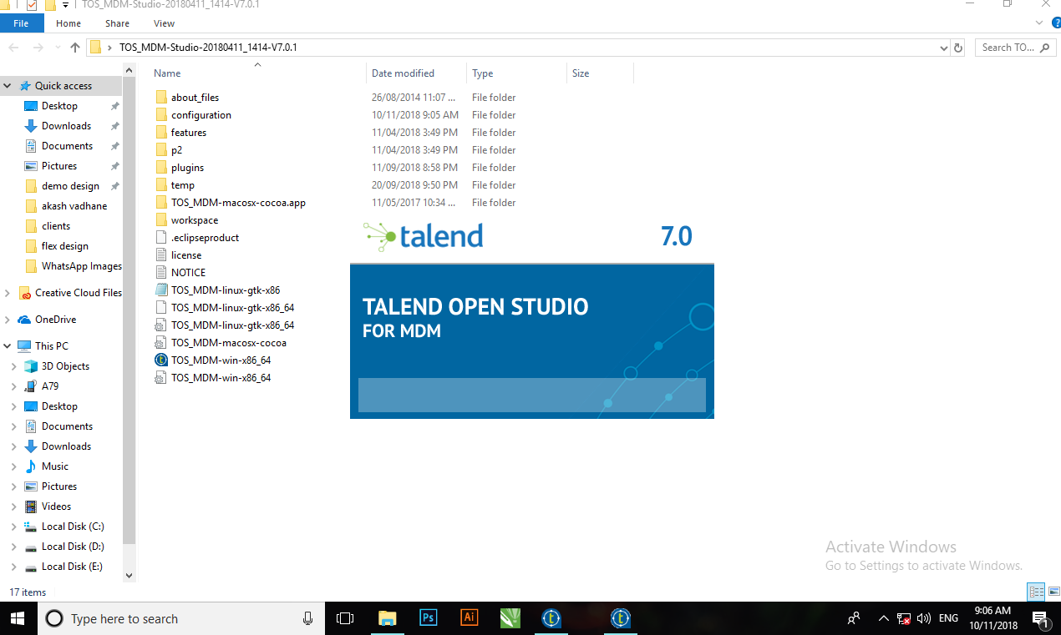

1. Create ***new project*** and give appropriate name to the project.

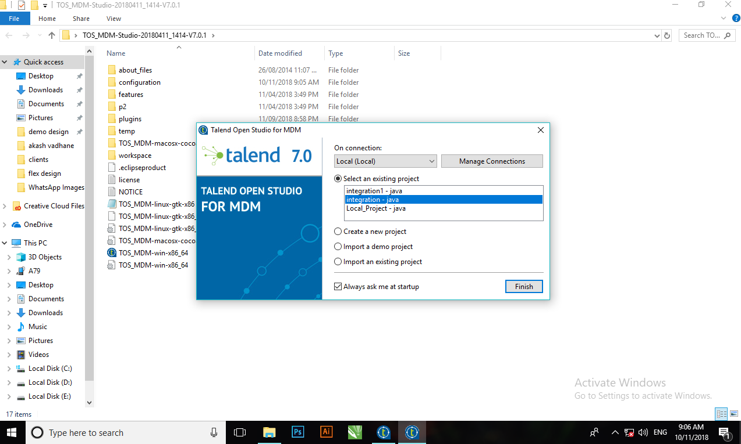

1. It will start loading.

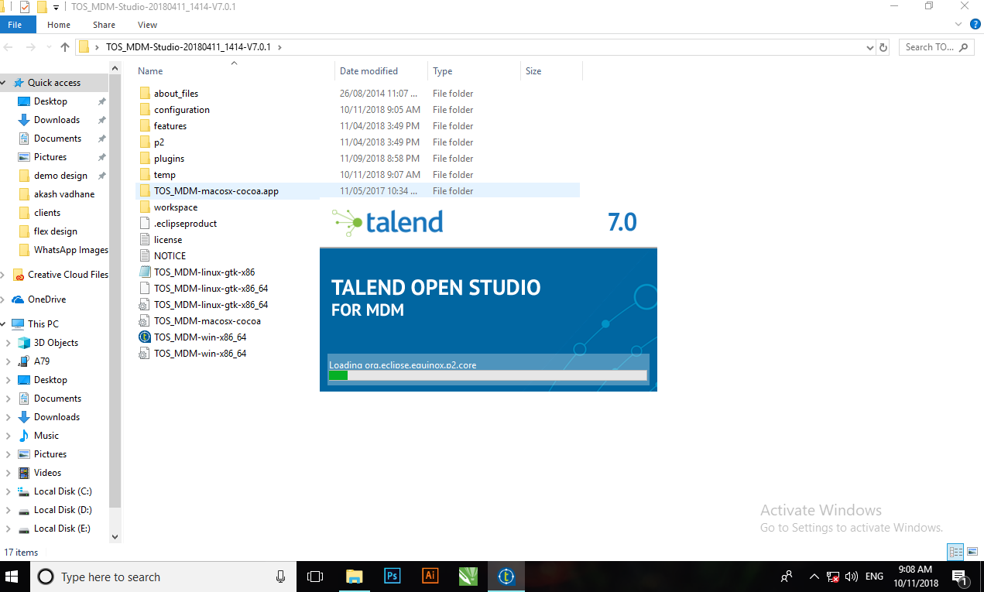

1. Then talend window like below, will be open

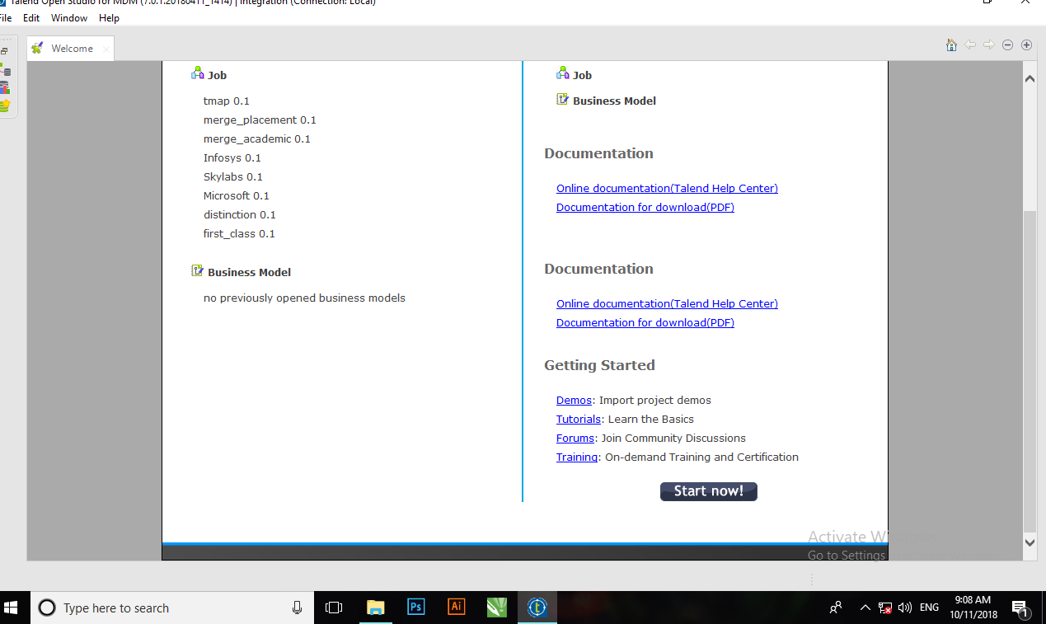

Click on ***start now*** option.

1. Then below window will be open

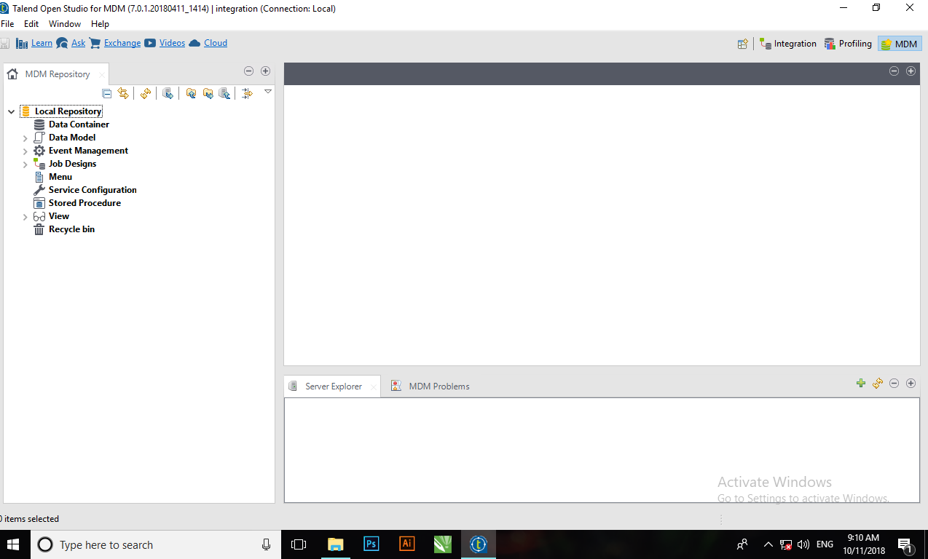

Click on ***integration*** option (at right corner).

* **How to create a job?**

1. Then this window will appear. To create a job, right click on ***job Design*** (at left side).

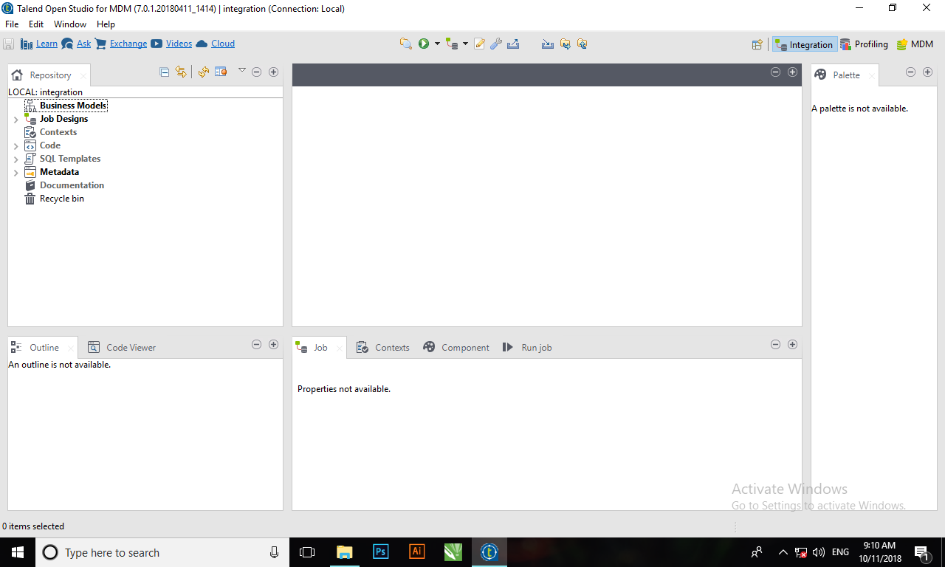

1. Now, these options will appear.

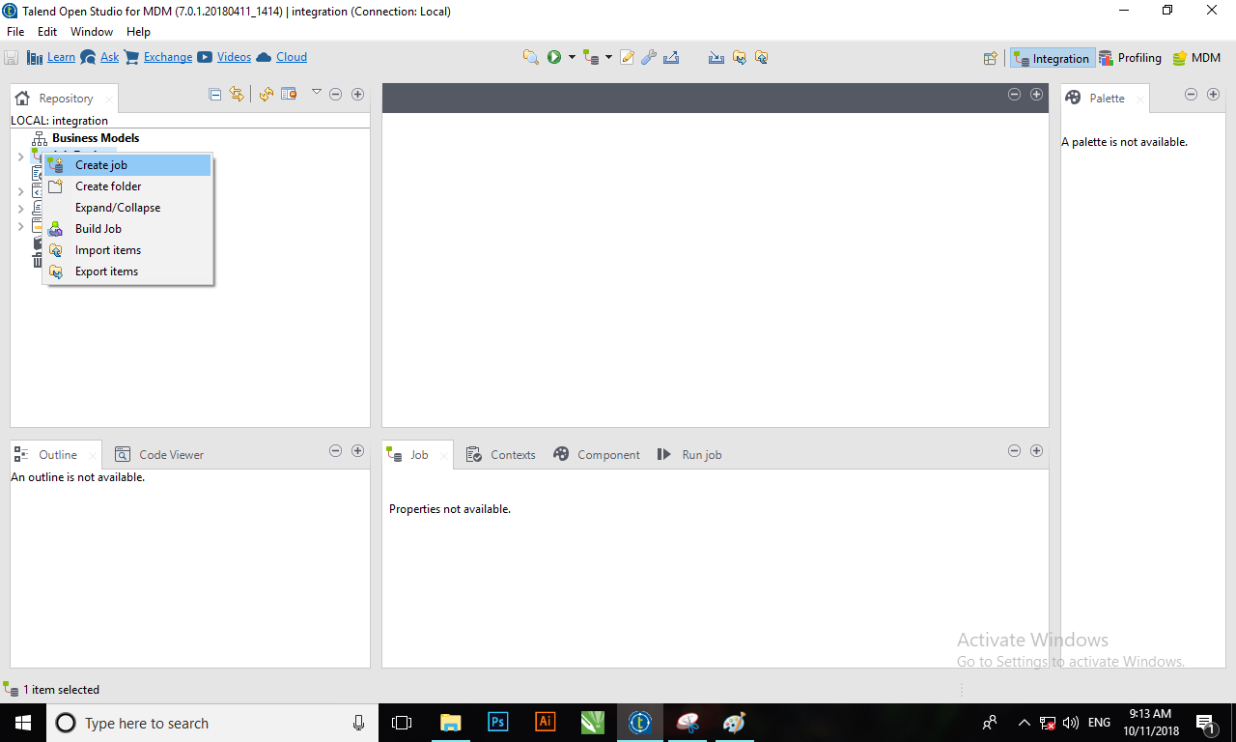

Select ***create job*** from that.

1. Then another window will appear.

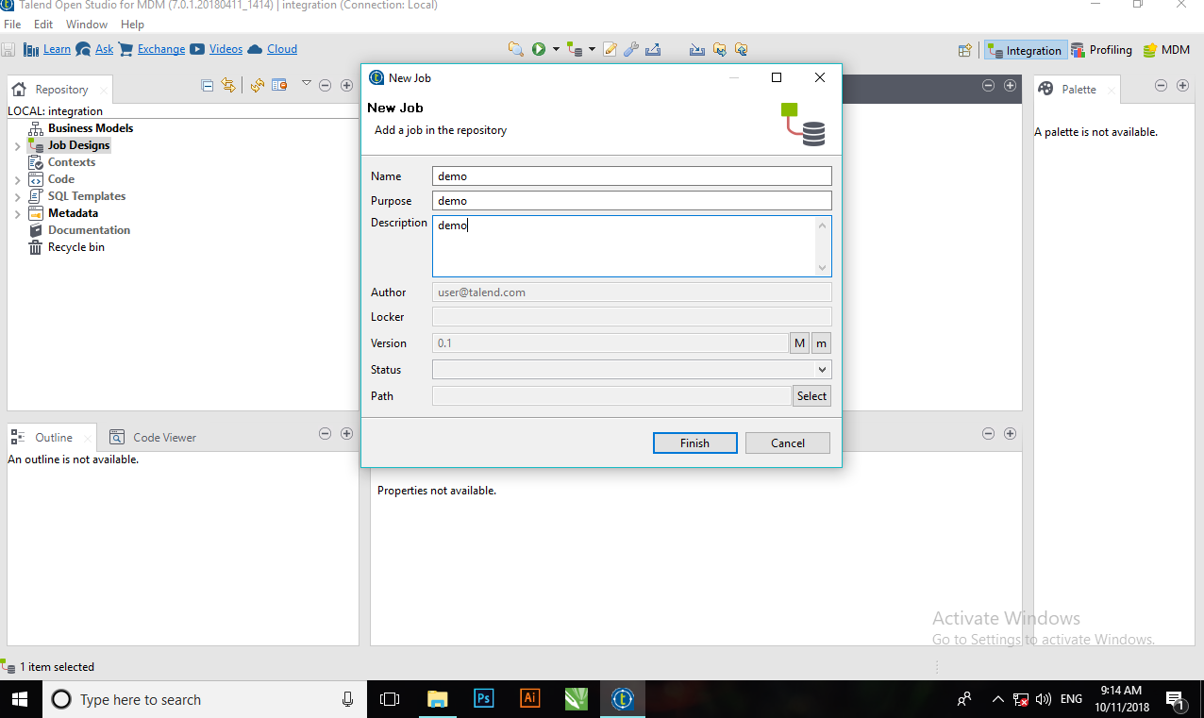

Fill the necessary information and click on ***finish***.

1. Your job will be created and the screen like below will appear.

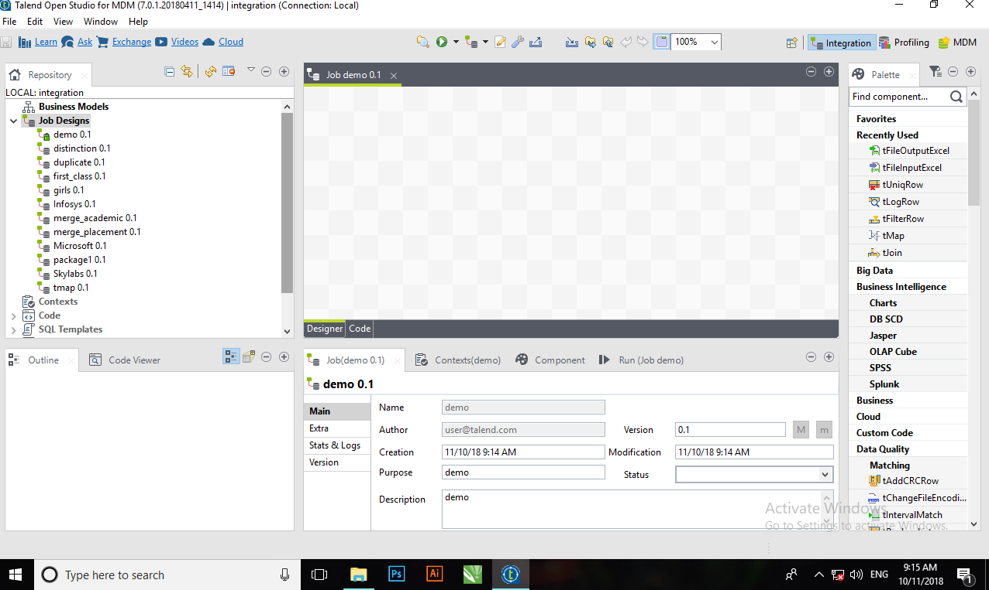

* **How to link different component in a job?**

1. You can see in above picture, there is small palette window at right side. You can search for any component from search bar or if you know location of the component then you can directly select it.

Now, we will see how to drag component into job.

Let’s search for tFileInputExcel. Now you can see tFileInputExcel in palette. Click on that and drag it into job. You can place it anywhere in the job.

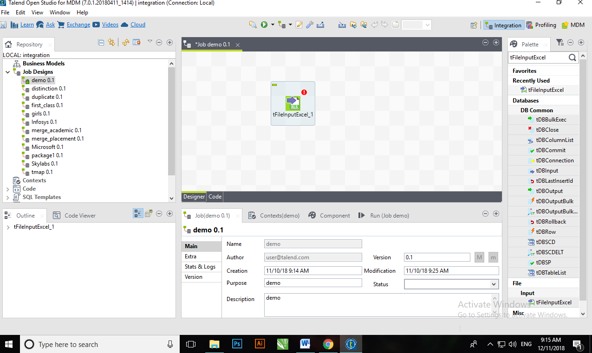

1. Then select another component from palette to see how to link one component to another component. Let’s select tfilterRow and drag it into job. Similarly, select tFileOutputExcel and drag it into job.

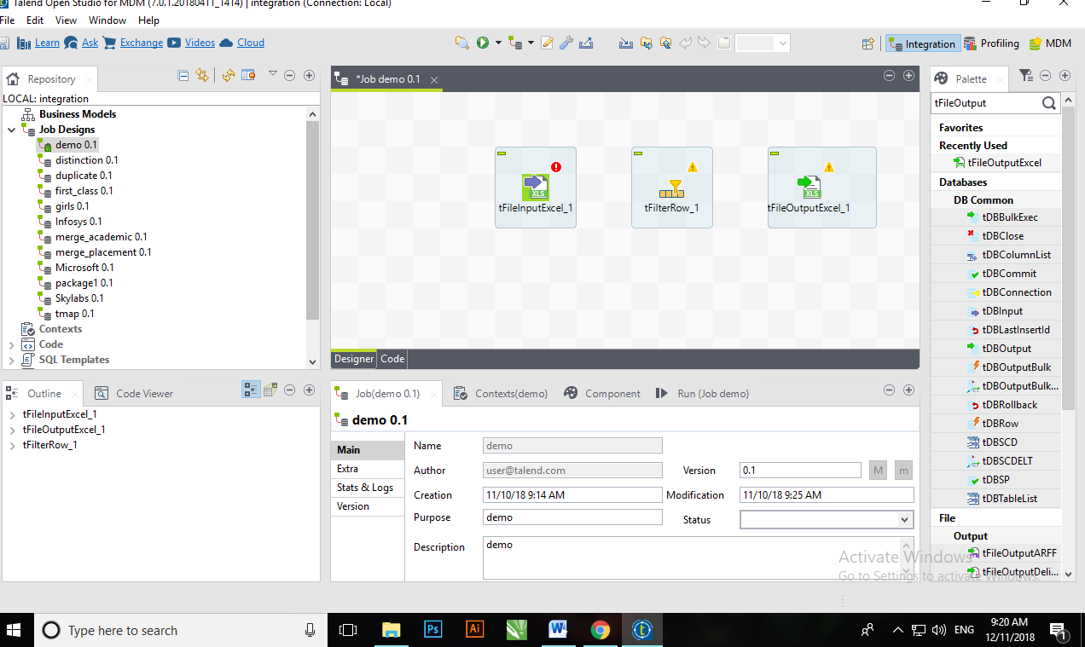

1. Then right click on tFileInputExcel then you can see few options. Bring cursor on Row, you will see three more options. Click on Main and connect that link to tFilterRow.

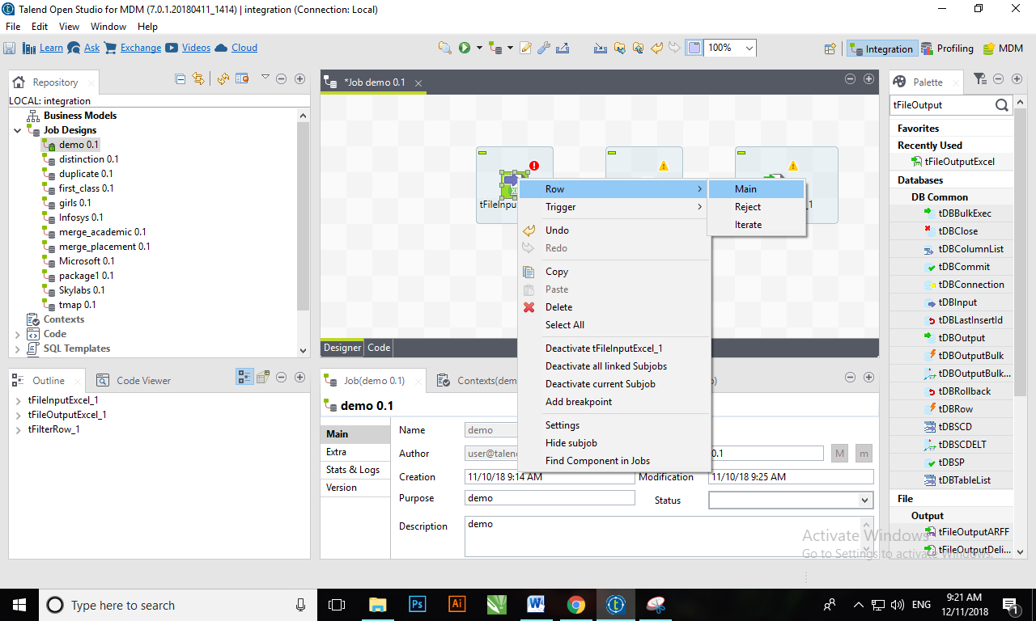

Similarly, you can connect tFilterRow to tFileOutputExcel via Row and Filter or reject option.

1. If you want to rename the component name, then you can double click on the component and give name of your choice.

* **Components:**

The components used to create job are divide into four families:

1. Input File
2. Output File
3. Processing
4. Logs and Errors

**Input File:**

1. To create new input file, click on ***metadata*** from repository section (at left side). 2.
2. Then right click on ***file excel*** and select ***create file excel***.

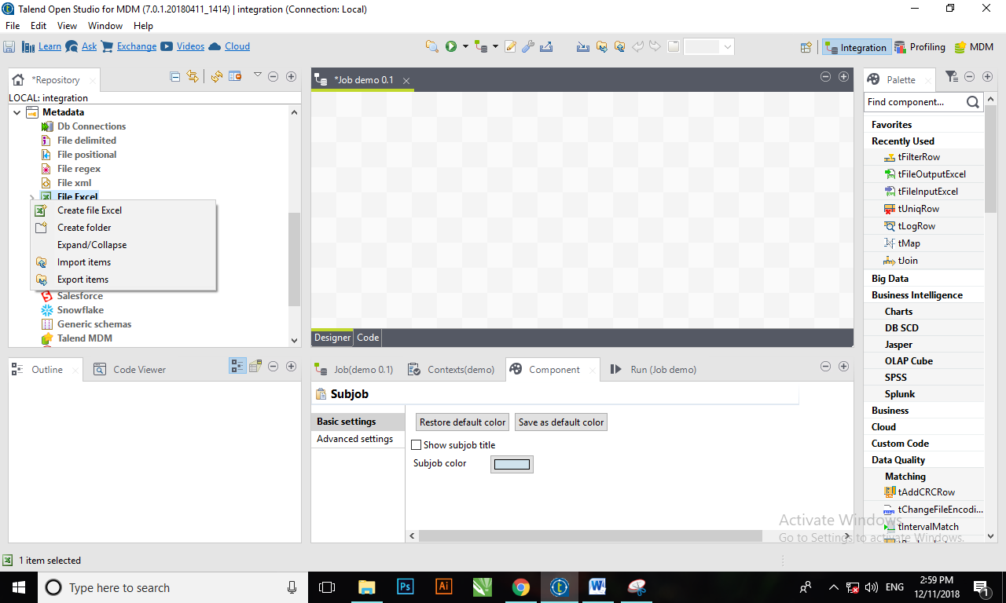

1. Then fill this form

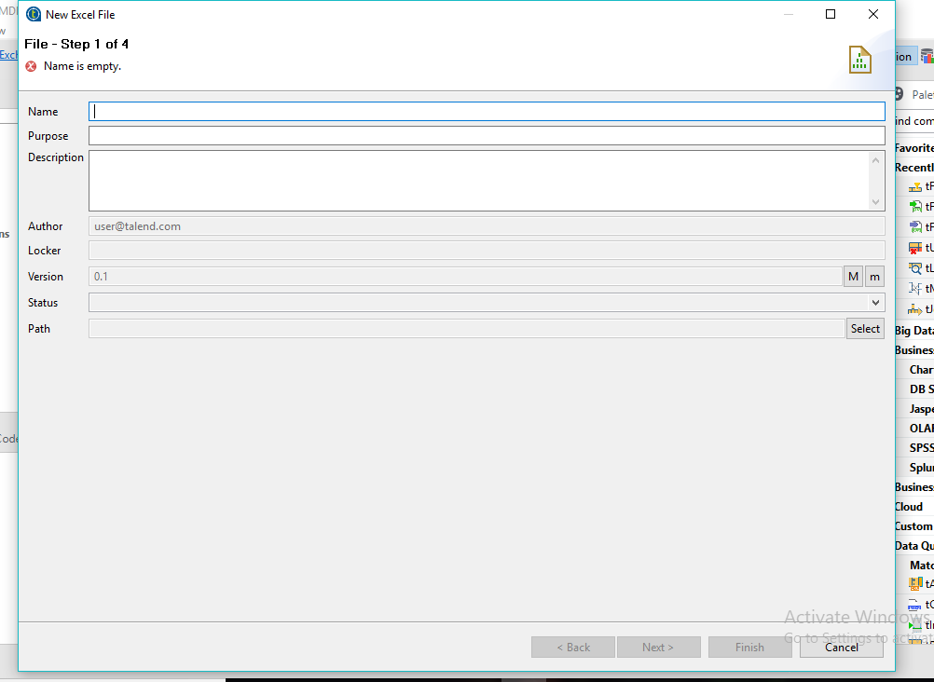 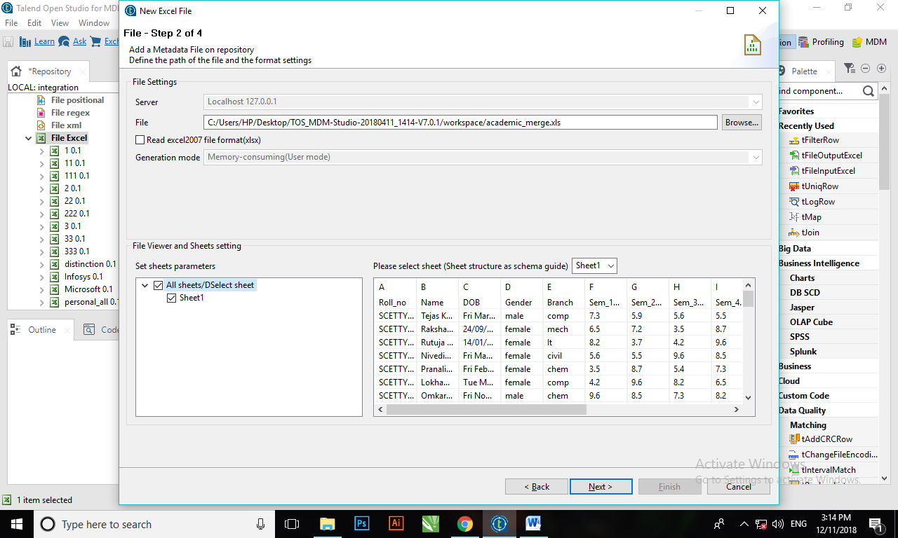

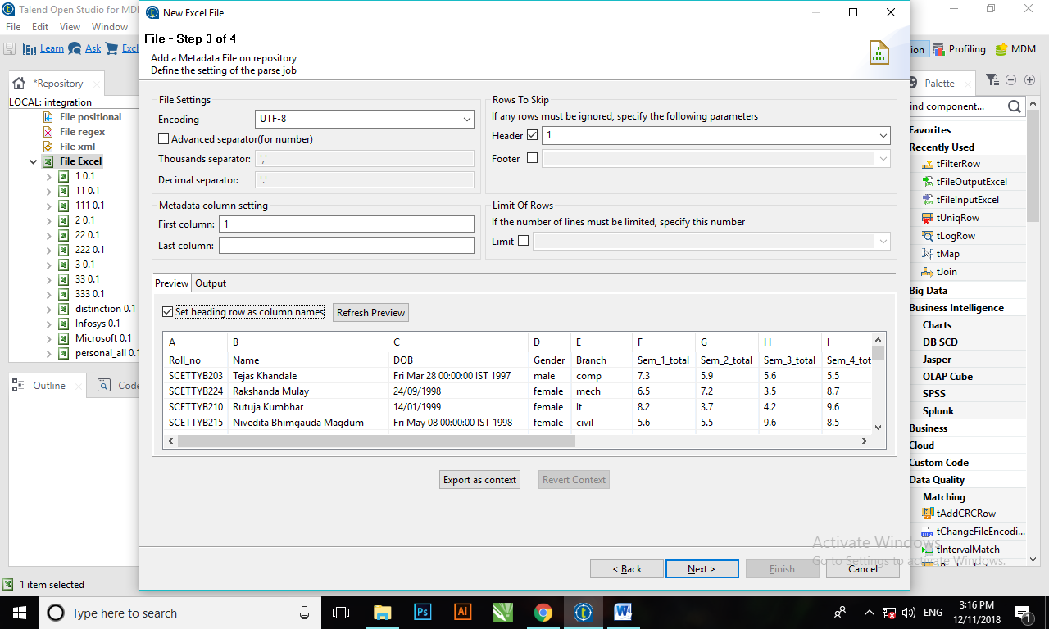 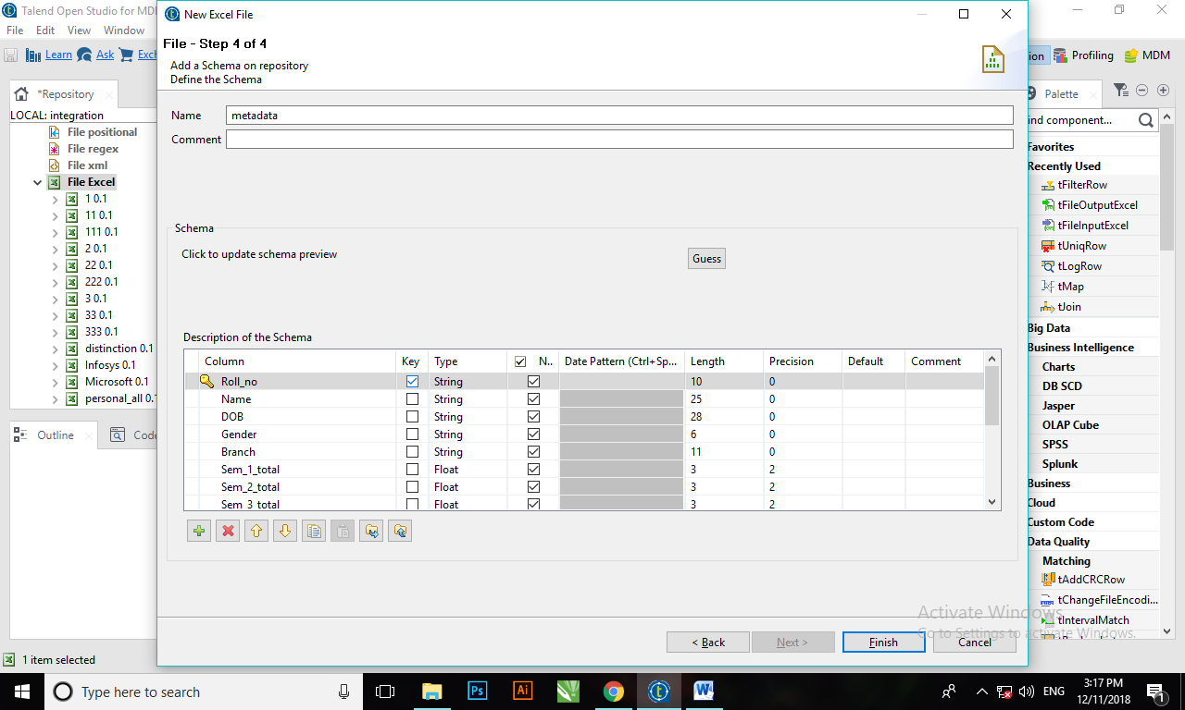

1. Then click on next.
2. Then browse your data sheet file and select sheet of that excel file and click on next.
3. Now your data will appear in preview section and then select the option ***set heading row as column names*** and click on next.
4. Then select primary key and click on ***finish***.
5. Now you can see your file has created. Now just drag it into the job. The small window will appear with two options.
6. Select ***tFileInputExcel*** from that and click on ***ok***. Now click on excel file and see the component section. You can all information about your file into that.

* **Processing:**

**tFilterRow:**

* tFilterRow filters input rows by setting one or more conditions on the selected columns.
* tFilterRow helps parametrizing filters on the source data.

1. To set condition for tFilterRow, click on tFilterRow component which is connected to tInputFileExcel.
2. Then click on ***component section*** which is at below of the job.
3. Then click on ***add*** button (+ sign button), one row will be inserted into that section.
4. Then click on ***InputColumn*** and select attribute of the file on which you want to set a condition.
5. Then select appropriate ***operator*** and insert proper value into column ***value***.
6. Then connect tfilter to tOutputExcel and ***run*** the job, you will find your output.

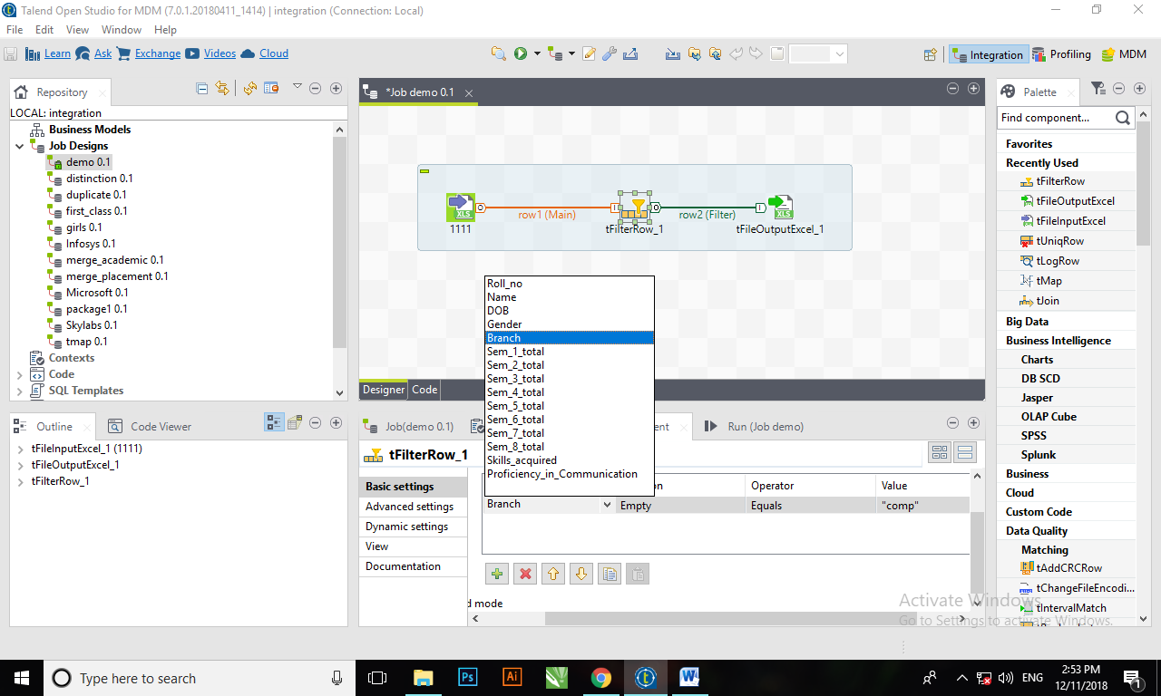

**tFilterColumns:**

* Makes specified changes to the schema defined, based on column name mapping.
* Helps homogenize schemas either on the columns order or by removing unwanted columns or adding new columns.
* With the help of tFilterColumn, you can add or delete existing column. For that click on ***component section*** and click on ***edit schema***. Then this window will appear. Now you can add or delete the column.

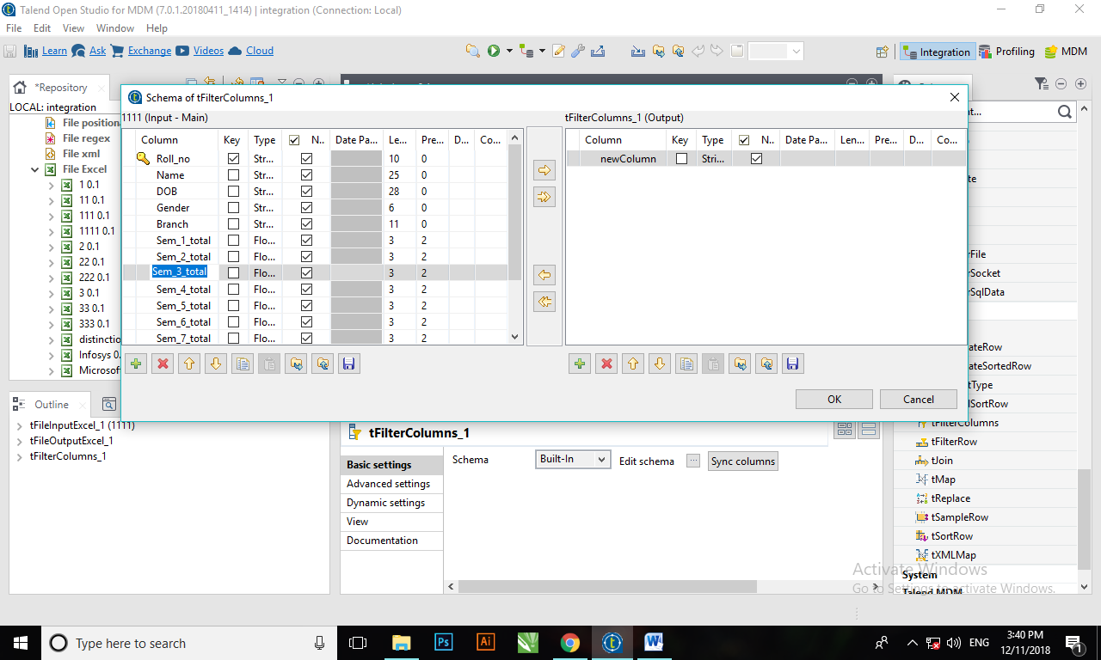

**tMap:**

* tMap transforms and routes data from single or multiple sources to single or multiple destinations.
* How to use tmap (for left outer join operation)?

1. Drag your ***input files*** into job and then ***drag tmap*** from palette.
2. Connect input files and tmap with ***row->main***.
3. ***Right click on tmap*** and then select output file.
4. Set ***path of output file*** from basic setting under component section.

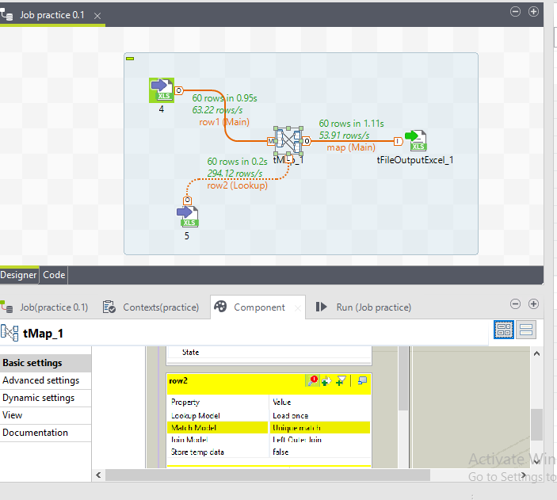

1. Then to set ***tmap setting*** click on [***…***] which is in front of map editor.
2. Now you can see another window. It will contain attributes of all input files. Then ***drag your key attribute*** of first file (row1) in front of key attribute of second file (row2). Then your expression key will be generated.
3. Now click on tmap setting of file2. In that select match model as ***unique match***.
4. And then select join model as ***left outer join***.

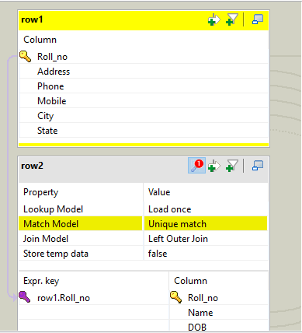

1. Now ***copy file1 attribute*** to the output file table.
2. Then ***copy all file2 attributes except key attribute*** because we have already copied it from file1 attribute.
3. Then click on ***Automap*** (at right corner). Now, you can see input files attributes and output files attributes are connected.
4. Then click on ***apply***. Now small window will appear click on ***yes*** and then click on ***ok***.
5. Now run the job and you can see result.

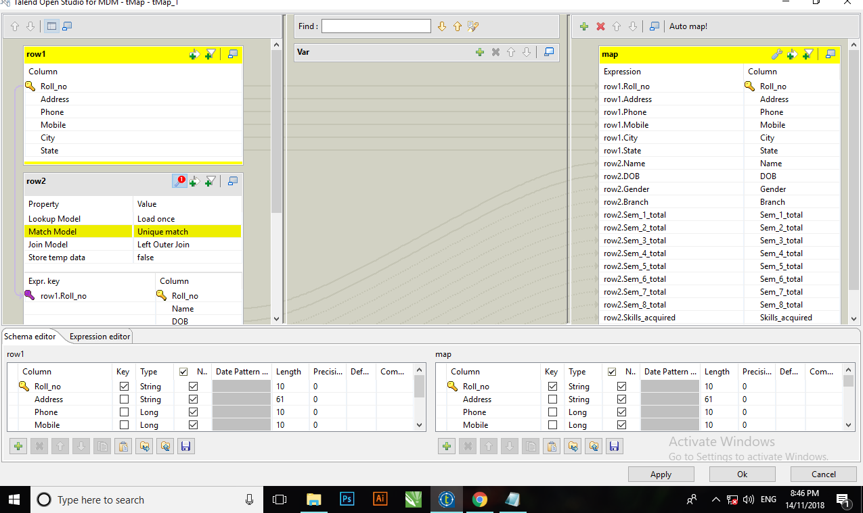

**tReplace:**

* Carries out a Search & Replace operation in the input columns defined.
* Helps to cleanse all files before further processing.
* How to use treplace?

1. Drag your ***input file*** into job and then ***drag tReplace*** from palette.
2. Connect input file and tReplace with ***row->main***.
3. ***Right click on tReplace***and then select output file.
4. Set ***path of output file*** from basic setting under component section.

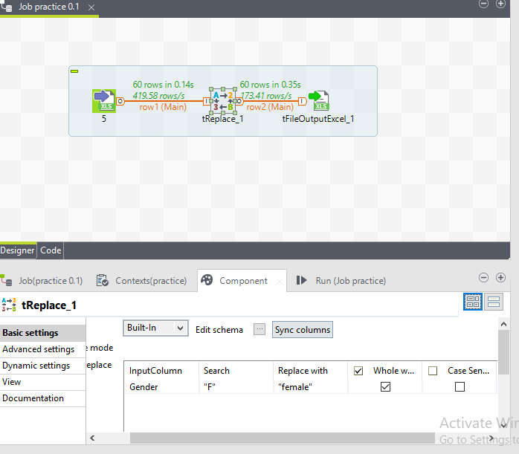

1. Then to set tReplace setting, click on ***tReplace*** and then in component section, under InputColumn, ***select column name*** of that respective value for which you want to search and replace.
2. Then under search column, ***enter the value to be search***.
3. Under Replace with column, ***enter new value***.
4. Then click on ***edit schema*** of tReplace and ***copy attribute*** which you want into table of output file. Then click on ***ok.***
5. ***Run*** the job or press F6.

**tSortRow:**

1. Sorts input data based on one or several columns, by sort type and order
2. Helps creating metrics and classification table.
3. How to use tSortRow?
4. Drag your ***input file*** into job and then ***drag tSortRow*** from palette.
5. Connect input file and tSortRow with ***row->main***.
6. ***Right click on tSortRow*** and then select output file.
7. Set ***path of output file*** from basic setting under component section

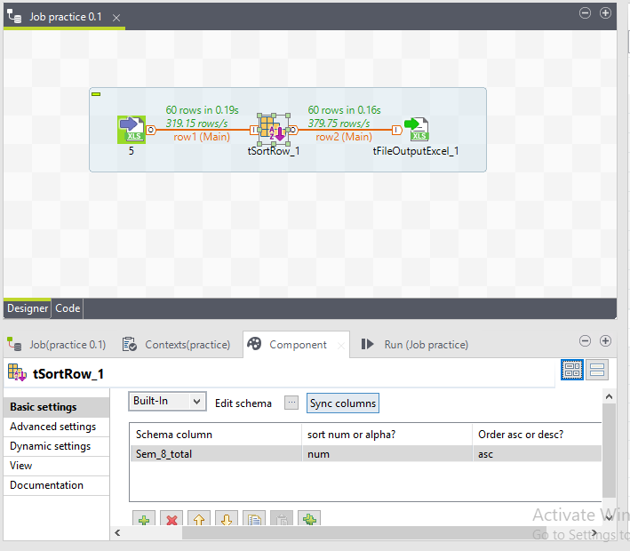

1. Click on ***tSortRow*** component. Then in component section, add one row in criteria table.
2. Then select ***column*** to order the data.
3. Select ***type*** of that ***data*** (num, alpha or date).
4. Select ***order type*** (ascending or descending).

**tUniqRow:**

* It removes duplicate records.
* How to use tUniqRow?

1. Select input file.
2. Drag tUniqRow, tLogRow from palette.
3. Then connect it with row->main.
4. Then click on tUniqRow. Now under component section, in basic setting, select unique key.
5. Run the job

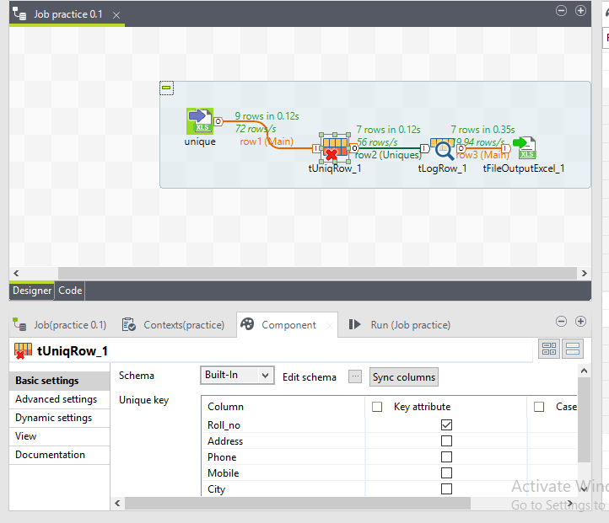

**tJoin:**

* tJoin joins two tables by doing an exact match on several columns. It compares columns from the main flow with reference columns from the lookup flow and outputs the main flow data and/or the rejected data.
* This component helps you ensure the data quality of any source data against a reference data source.
* **Logs and Errors:**

**tLogRow:**

* Displays data or results in the Run console.
* tLogRow is used to monitor data processed.
* **Output File:**

tOutFileExcel:

to create output file, select tOutFileExcel from palette and drag into the job. Then if you want to change the location of output file, you can change it from component section. Also you can include header to your output file.

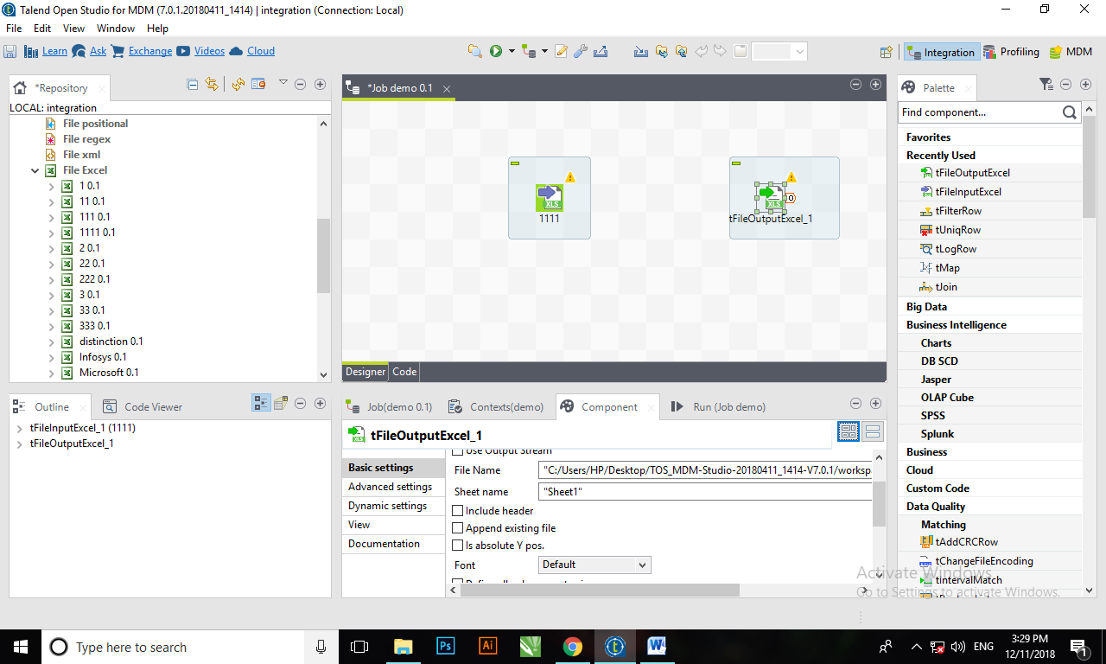

* **How to Define Component Properties?**

The properties information for each component forming a Route allows to set the actual technical implementation of the active Route.

Each component is defined by basic and advanced properties shown respectively on the Basic Settings tab and the Advanced Settings tab of the Component view of the selected component in the design workspace. The Component view gathers also other collateral information related to the component in use, including View and Documentation tabs.

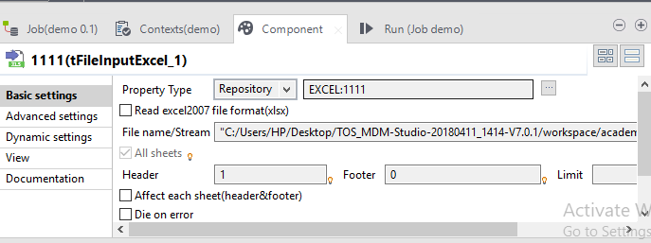

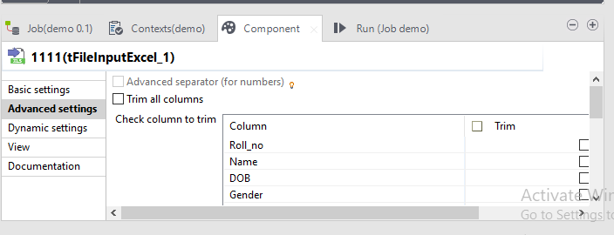

* **How to use context and variables in a job?**

If we consider a simple scenario where in a simple job we read data from a file and store it in a database that is configured as built-in, with the connections specified. This job will run perfectly run in test or development environment. However, to export and run the job in pre-production or production environment then we need to change connection variables manually. To avoid this we use context variables.

Context variable groups are groups of variables for which the values change depending on the context in which the job is run.

**STEPS**

1. Create a repository context group.

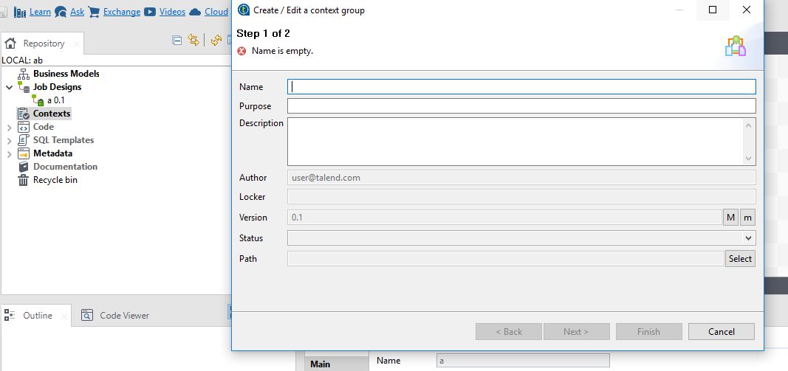

Then specify necessary details

After finishing it will appear in contexts.

2. To use it in job import it.

3.The imported variables can be accessed in the Job by using the prefix "context." plus the variable name. In the Component view of the MySql component, replace the fixed values from the configuration with the corresponding variable from the context group.

* **How to run a job?**

To run your click on run section and in that section, click on run button.

Or

At the top of the window, there is one green button, click on that to run the job.

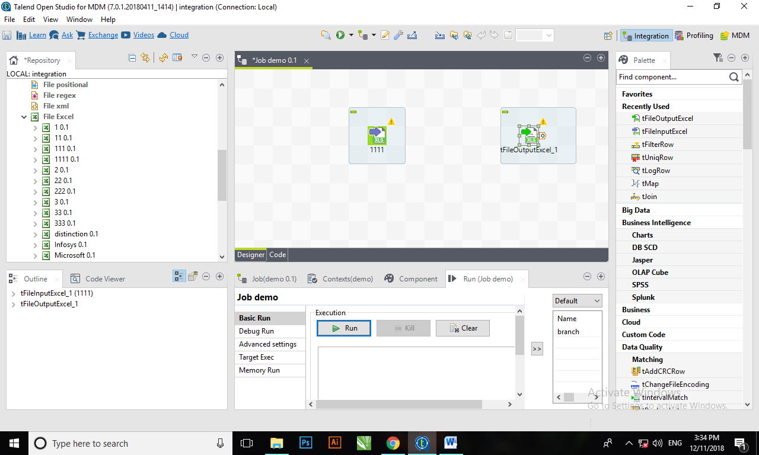

**Explains different ways you can optimize a jobs performance.**

1. Parallel executions of multiple Subjobs.

2. Parallel iterations for reading data.

**How to Import/Export Items and Build Jobs?**

**How to export Items?**

1. In the Repository tree view, select the items you want to export.
2. Right click on that and select export option.
3. Click Browse to browse to where you want to store the exported items.
4. Click Finish to close the dialog box and export the items.

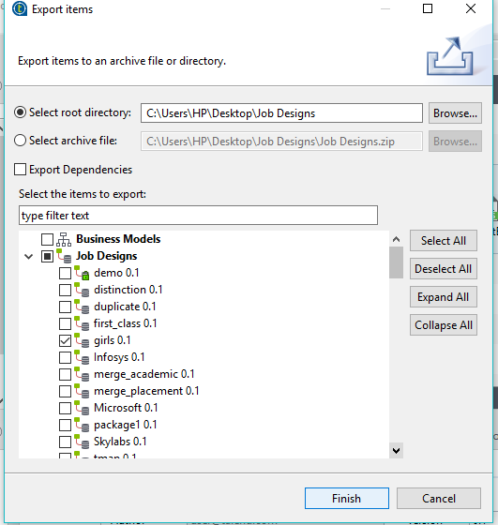

**How to import a job?**

1. Right click on job analysis.

2. Then select option import.

3. Then browse the file which you want to import

4. And then click on finish.

